Multilingual News/Article Website (Next.js/Strapi/Postgres)
Software Requirements Specification

Version 1.0

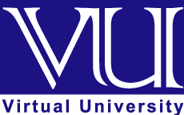

Group Id: F23020A0A3
Supervisor Name: Usama Umar

Revision History

Date (dd/mm/yyyy) | Version | Description | Author
08/12/2023 | 1.0 | SRS document includes project’s specifications, functional and nonfunctional requirements, use case diagram and scenarios, work plan with adopted methodology to be used during software development life cycle | BC200412005

Table of Contents

- Scope (of the project)
- Functional Requirements Non Functional requirements
- Use Case Diagram
- Usage Scenarios
- Adopted Methodology
- Work Plan

SRS Document

Scope of Project:

The purpose of this document is to outline the software requirements for the development of a Multilingual News/Article Website using the Jamstack architecture. The website aims to provide news content in both Urdu and English languages and includes features such as a Content Management System (CMS), content localization, static site generation, language switcher, internationalization, SEO optimization, responsive design, and administrative roles.

Functional and non-Functional Requirements:

Functional requirement:

Here are the key functional requirements for such a website:
1. Content Management System (CMS): Choose a headless CMS that supports multiple languages and allows for easy content creation and management. Popular options Strapi.
2. Content Localization: Ensure that your chosen CMS provides support for content localization, allowing you to store and manage content in multiple languages.
3. Static Site Generator (SSG): Select a Jamstack-friendly SSG Next.js to generate static HTML files for your website. These SSGs can easily handle multilingual content.
4. Language Switcher: Implement a language switcher on your website that allows users to switch between different languages (Urdu/English only). This can be a dropdown menu, flags, or text links, depending on your design.
5. Internationalization (i18n) Library: Utilize an i18n library like react-i18next or vue-i18n to handle text translations within your web application. This will help manage translations within the user interface.
6. URL Structure: Develop a clear and SEO-friendly URL structure that includes language codes (e.g., example.com/en/news) to differentiate content for search engines and users.
7. SEO Optimization: Implement proper meta tags for each language version of your content to improve SEO and search engine ranking in different regions.
8. Responsive Design: Ensure that your website is responsive to various screen sizes and devices to cater to a diverse audience.
9. Feedback Mechanism: Provide the user to comments on your news or articles
By meeting these requirements, you can develop a robust and user-friendly multilingual news
website using the Jamstack architecture.
10. Subscription Renewals and Notifications: Implement renewal reminders and notifications for users in their chosen language to ensure they don't miss important subscription events.

Non-Functional Requirements:
Performance:
As this is a web application so it can run on almost every computer. Its functions and features are not computationally demanding. There is no need of a powerful processor or graphics card, much RAM, or disk space. It only needs a latest browser.

Scalability:
The system should be designed to handle a scalable increase in users and content. It should accommodate a 20% growth in user traffic and content volume within a six-month period.
Availability:
The website should aim for 99.9% uptime, allowing for scheduled maintenance. The downtime for scheduled maintenance should be communicated to users in advance.
Error handling:
Proper error handling mechanisms should be in place, providing meaningful error messages to users and logging detailed error information for debugging purposes.

Data Encryption
Sensitive user data and communications, including login credentials, should be encrypted using secure protocols (HTTPS).

Use Case Diagram(s):

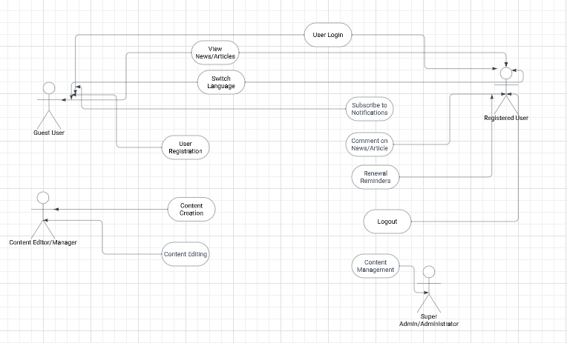

Usage Scenarios:

Use Case Title | Viewing News/Articles in English or Urdu
Use Case Id | 1
Actors | Guest User or Registered User
Description | A user visits the website and navigates to the homepage.
Actions | - A user visits the website and navigates to the homepage.
Action: | - The user selects their preferred language (English or Urdu) using the language switcher.
Pre-Conditions | - The system displays news/articles in the selected language.
Result | : The user can seamlessly switch between English and Urdu content.
Author | bc200412005

Use Case Title | User Registration and Login
Use Case Id | 2
Actors | Guest User
Description | A new user wants to access personalized features on the website.
Actions
Action: | - The user clicks on the "Register" link and fills in the required information.  - The user logs in with the newly created credentials.
Pre-Conditions | - The system validates the information and creates a new user account.
Result | : The user is now registered and logged in, enabling access to additional features.
Author | bc200412005

Use Case Title | Content Creation by Editor/Manager
Use Case Id | 3
Actors | Content Editor/Manager
Description | An editor wants to create a new article for the website..
Actions
Action: | - The editor logs in and navigates to the content creation section.  - They fill in the article details, including title, content, and language.
Pre-Conditions | - The system saves the article in the CMS.
Result | :The new article is now available on the website for users to view
Author | bc200412005

Use Case Title | Commenting on a News/Article
Use Case Id | 4
Actors | Registered User
Description | A user wants to provide feedback on a news article..
Actions
Action: | - The user reads a news article and decides to leave a comment.  - They enter their comment in the provided section.
Pre-Conditions | - The system saves the comment and associates it with the respective article.
Result | : The user's comment is displayed on the article page, contributing to user engagement.
Author | bc200412005

Use Case Title | Super Admin Managing Users
Use Case Id | 5
Actors | Super Admin/Administrator
Description | A super admin needs to manage user accounts on the website..
Actions
Action: | - The super admin logs in and navigates to the user management section.  - They can view a list of registered users, including their details.
Pre-Conditions | - The system allows the super admin to modify user roles or deactivate accounts.
Result | : The super admin effectively manages user accounts for the website.
Author | bc200412005

Use Case Title | Subscription Renewal Reminder
Use Case Id | 6
Actors | Guest User or Registered User
Description | A user with a subscription wants to receive renewal reminders.
Actions
Action: | - The user subscribes to a newsletter or premium content.  - The system records the subscription and schedules renewal reminders
Pre-Conditions | - The user receives renewal reminders in their chosen language when the subscription is due for renewal.
Result | : The user stays informed about subscription renewals in their preferred language.
Author | bc200412005

Adopted Methodology:
The adopted methodology for this project is vu process model. Vu process model is a combination of water-fall model and spiral model. This combination has many advantages. This model has high risk analysis so avoidance of risk would be achieved. This model is easy to understand and use. Now first we will discuss the Water-fall model.
WATER FALL MODEL:

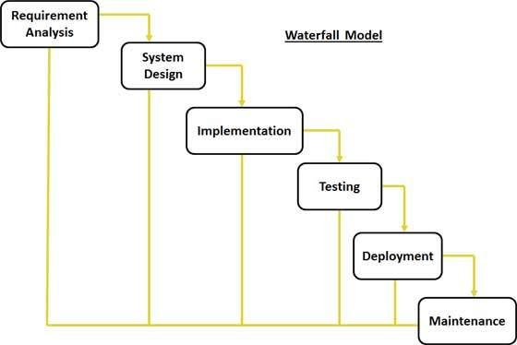

The Waterfall Model was first Process Model to be introduced. It is also referred to as a linear-sequential life cycle model. It is very simple to understand and use. In a waterfall model, each phase must be completed before the next phase can begin and there is no overlapping in the phases. Waterfall model is the earliest SDLC approach that was used for software development. The waterfall Model illustrates the software development process in a linear sequential flow; hence it is also referred to as a linear-sequential life cycle model. This means that any phase in the development process begins only if the previous phase is complete. In waterfall model phases do not overlap. Water fall model have different stages which is starting from requirements phase and ends at acceptance phase.

Requirement Gathering and analysis:
All possible requirements of the system to be developed are captured in this phase and documented in a requirement specification doc.
System Design:
The requirement specifications from first phase are studied in this phase and system design is prepared. System Design helps in specifying hardware and system requirements and also helps in defining overall system architecture.
Implementation:
With inputs from system design, the system is first developed in small programs called units, which are integrated in the next phase. Each unit is developed and tested for its functionality which is referred to as Unit Testing.
Integration and Testing:
All the units developed in the implementation phase are integrated into a system after testing of each unit. Post integration the entire system is tested for any faults and failures.
Deployment of system:
Once the functional and non functional testing is done, the application will be deployed in the user environment.
Maintenance:
There are some issues which come up in the user environment. To fix those issues patches are released. Maintenance is done to deliver these changes in the user’s environment.
Now we will discuss the spiral model and Vu model.

SPIRAL MODEL:

1. To eliminate the risk that could be faced in development of software the use of spiral methodology is adopted. For example, the risk might be a resignation from the key person
2. Spiral Model has two dimensions. One is Radial dimension which represents the cumulative cost to date, and the other is angular dimension which represents the progress through the spiral.
3. The spiral model is very sensitive to risks. In this model development and maintenance run in parallel. This method is used for development of large-scale and in-house software.

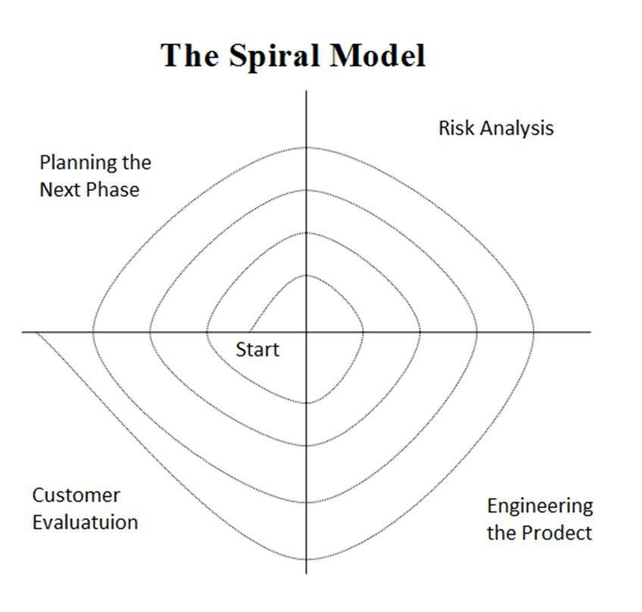

VU PROCESS MODEL:
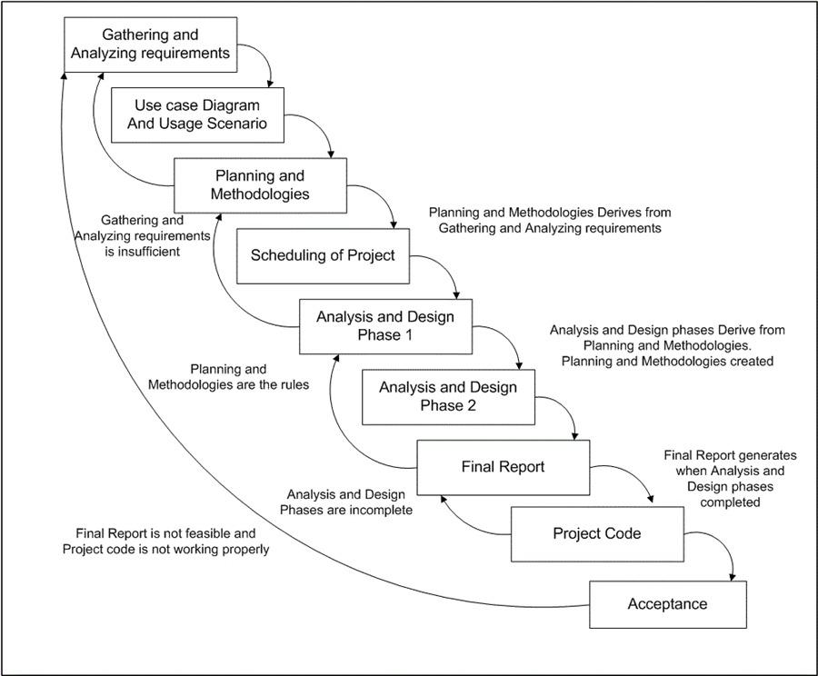

This process model is combination of water fall and spiral model. This process model maximizes the quality of system and reduces the risk and disadvantages
Reason to choose the VU process model:
Our task is isolated as of now into various stages for example assembling and examining prerequisites stage, arranging stage, examination and configuration stage, improvement and last undertaking report stage, and last report/viva stage.

We will finish each stage in succession and will submit it to our supervisor. He will recommend us about the improvement in each stage before beginning the following stage. We will make improvement in that stage. This procedure will be embraced because of the winding idea of VU Procedure model. At the point when the stage is well-improved and very much worked-out, and furthermore acknowledged by our supervisor then we will continue to next stage. This will be done because of the cascade idea of the VU Procedure model. Consequently the two models are smothered in single structure and that will be our VU procedure model. It will give mistake free outcome as each progression is done in a succession.

Mix of both waterfall and spiral method is considered half and half methodology of framework improvement that augments the nature of framework and limits the hindrances and hazard. VU process model has four stages which further partitions the cascade forms. These procedures are in emphasis until framework meets to client prerequisite.

Work Plan

